VOLUNTEERING APPLICATION FORM
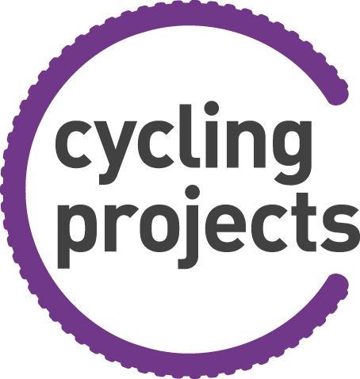
Cycling Projects

Personal Details
Title:
First name(s):
Last name:
Known as:
Date of Birth:
Address:
Postcode:
Contact Number:
Mobile Number:
Email address:
Have you volunteered before if YES please tell us about it

What type of volunteering would you like to do?
If you are more flexible it will be easier to find opportunities

Administration [ ] Finance/Accounting [ ]
Cycle ride support [ ] Fundraising [ ]
Mechanics & Maintenance Support [ ] Wheels for All Based Support [ ]
Events /Tasters Delivery [ ] Charitable and Promotion [ ]
Computers Technology [ ] Website support [ ]
Newsletter development [ ]

Any other area_____________________________________

Please tell us why you would like to become a volunteer

How did you find out about volunteering with Cycling Projects?
Staff Member/Passing By [ ] Friend [ ]
Cycle Projects Website [ ] Event [ ]
Cycle Projects Twitter [ ] Volunteer Centre [ ]
Cycle Projects Facebook [ ] Other [ ]
Newspaper [ ]
Existing Participant [ ]

Present/previous occupation and what skills, knowledge, experience or abilities do you have that maybe relevant to this role?

Do you have any health issues or disabilities that we may need to consider when matching you to a volunteer role?
Do you have any convictions, cautions, reprimands or warnings?
(Please disclose any convictions, cautions, warnings, reprimands and previous or pending investigations as these will all appear on DBS checks)

Which area / region would you most like to volunteer in?

Would you be willing/able to travel to other nearby opportunities? YES NO

Please tick when you could be available to volunteer

 | Mon | Tue | Wed | Thu | Fri | Sat | Sun
AM
PM
EVE

Any other information regarding availability. Ex: (every other Sunday)
How can we communicate with you?
To enable us to keep in touch with important updates to support you as a volunteer, such as training events, meetings, resources or Cycling Projects news. Please let us know how you wish to be contacted, you can change this at any time. Likewise, please do let us know if your contact details change. If you change your mind about any of your choices or have any concerns about any communications from us, please contact the National Volunteer Coordinator.

I am happy for my data to be used to contact me about: (tick all that apply)

Cycling Projects newsletter
Volunteers newsletter including training, events, opportunities and social activities
Other volunteering opportunities
How I can get involved in Fundraising
Ways to provide financial support
I am happy to be contacted via: (tick all that apply)

Email
Post
Telephone
Text

DATA PROTECTION STATEMENT

Cycling Projects will process and be in control of the data provided on this form.
The information which you provide in this form and any other information obtained or provided during the course of your volunteering with us (“the information”) will be used for the purpose of assessing your suitability for roles, in emergency situations e.g. to protect life or in a medical situation, and in relation to relevant interests of Cycling Projects.

If you choose not to volunteer, the information will be retained for a further 6 months in the event of a more suitable opportunity arising, after which time it will be destroyed.

You have the right to data portability, request access to, rectification or erasure of your data collected as part of this process.

If your application is successful, the information will form part of your volunteer file and we will be entitled to process it for all purposes in connection with your voluntary role.

So that we may use the information for the above purposes and on the above terms, we are required to obtain your explicit consent. Accordingly, please sign the consent section below. You have the right to withdraw your consent at any time and the right to lodge a complaint with the Information Commissioner.

I CONSENT TO MY PERSONAL INFORMATION BEING USED FOR THE PURPOSES AND ON THE TERMS SET OUT ABOVE.

Signed: Date:

Please return this form to:

Post:
Tom Glynn
National Volunteer Coordinator
11-13 Wilson Patten Street
Warrington
Cheshire
WA1 1PG

E-mail:
Tom.glynn@cycling.org.uk

